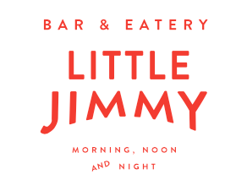

Valentine’s Day 2020
Choice of
West Coast trevally, coconut, lime, chili (df,gf)
Pork arancini, red wine vinaigrette, pomegranate, almonds
Chargrilled eggplant and courgettes, buffalo mozzarella, truffle oil (gf,v)

Choice of
Pan fried market fish, white bean broth, cavolo nero, paprika (df,gf)
Freedom Farms pork belly, celeriac, roasted aubergine, pickled shallots (df,gf)
Goat loaf, pistachio, buffalo curd, pickled onions (gf)
Potato gnocchi, asparagus, spinach, peas, courgette (v,df)

Dark sweet cherry and Vietnamese mint sorbet

Choice of
Dulce de Leche cheesecake, chocolate soil, fresh berries, kiwifruit sorbet (gf)
Warm sticky date pudding, butterscotch, vanilla ice cream

Sides as extras
Curly fries, chipotle aioli 10 Chargrilled sweetcorn 12 Apple and carrot slaw 10

