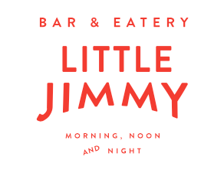

for the table

Fresh sourdough + Lot 8 extra virgin olive oil
Charcuterie sharing boards
Local artisanal meats, duck liver parfait, house made pickles

Beef short rib, tamarillo relish, miso, heirloom carrots, confit turnip
Freedom Farms pork belly, butternut, lentils, chorizo feijoa
Pan fried market fish, swede, beetroot, freekeh

Sauteed kalettes + curly fries w chipotle aioli

Roasted spiced pear, honeyed walnut, dark chocolate, almond ice-cream

Whittaker’s 72% chocolate fondant, coconut & lime sorbet, lemon cream

